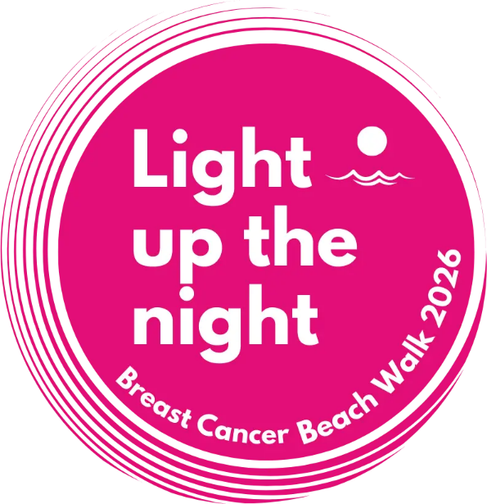

Name ____________________________________ E-mail Address _____________________________________
Date of birth (MM/DD/YY) _________________ Telephone Number __________________________________
Male/Female Shirt Size: S M L XL 2XL Youth S/M/L
T-shirts available on a first come/first served basis PICK UP week FEBRUARY 21st or 28th 9 am to 4.30pm ONLY
at our office, #19 Grand Harbour – 923 1135 – 938 1134

REGISTRATION FORM
LIGHT UP THE NIGHT – BREAST CANCER FOUNDATION BEACH WALK
Saturday 7th March 2026 PUBLIC BEACH
Registration from 5.30pm, walk at 6.30pm
ENTRY FEE $30 (children under 10 free)
Sign up and pay online at www.breastcancerfoundation.ky

WAIVER OF LIABILITY
I ACKNOWLEDGE THAT walking is a potentially hazardous activity and carries with it the risk of injury or death. I, the under- signed, hereby assume the risk of participating in the ‘Light up the Night – Breast Cancer Beach Walk’ scheduled on the 7th March 2026
I CERTIFY that I am physically fit and have not been advised against participating by a qualified health professional.
IN CONSIDERATION of your accepting this entry, I hereby agree on behalf of myself, my executors, administrators, heirs, next of kin, successors, assigns, and any other person who may claim or sue on my behalf, the following:
a) to abide by any and all rules as provided by the organizers of the walk
b) to WAIVE, RELEASE and FOREVER DISCHARGE from any and all claims, losses, economic or otherwise, or liabilities for
death, personal injury, partial or permanent disability, damage to property, all payment relating to medical costs or costs of hospitalization, theft or damages of any kind, which may arise as a result of or relate to my participation in the said Walk, the following persons
or entities: THE BREAST CANCER FOUNDATION, THEIR DIRECTORS, MEMBERS, AGENTS AND OFFICERS, EVENT SPONSORS, RACE DIRECTORS, RACE PRODUCERS, VOLUNTEERS EVEN WHERE SUCH CLAIMS, LOSSES OR LI- ABILITIES ARE CAUSED AS A RESULT OF THE NEGLIGENT ACTS OR OMISSIONS OF THE PERSONS OR ENTITIES I AM HEREBY RELEASING OR ARE CAUSED BY THE NEGLIGENT ACTS OR OMISSIONS OF ANY OTHER PERSONS OR ENTITIES;
c) to assume the risk of running/walking including but not limited to falls, contact with other participants, effects of weather including but not limited to heat and/or humidity, defective equipment, road condition, water hazards, any hazards that may be posed by spectators or volunteers, all risks being known and appreciated by me; and I further acknowledge that these risk include risks that may be the result of the negligence of the persons or entities mentioned above for any of the claims, losses, liabilities that I have waived, released or discharged herein;
d) to agree not to sue any of the persons or entities mentioned above for any of the claims, losses, liabilities that I have hereby waived, released or discharged herein;
e) to indemnify and hold harmless the persons and/or entities mentioned above from any and all expenses incurred, claims made, or liabilities assessed against them including but not limited to attorney’s fees and litigation expenses arising out of or resulting directly or indirectly from, in whole or in part from (i) my actions or inactions (ii) my breach or failure to abide by any part of this Waiver including but not limited to my covenant not to sue (iii) any breach on my part in abiding by any rules provided by the organizers or (iv) any other harm caused by me;
f) to grant permission for the use of my name and or my likeness in the ‘Light up the Night – Breast Cancer Beach Walk’ and to waive any and or all future compensation to which I may otherwise be entitled as a result of the use of my name and likeness;
g) to confirm that I understand that the entry fee is non-refundable and that the event may be cancelled due to weather conditions and/
or natural disasters;
h) to confirm that I am eighteen years (18) of age or older, that I have read the Waiver and I understand its con-tents or that I am a Minor and that my parent(s) and or legal guardian agree(s) and accept(s) to be bound by the terms and conditions contained within the Waiver.

Signature _________________________________________ Date ________________________________

Name (print) ______________________________________

Parent/legal guardian signature _________________________________ Relationship to minor _________

